Creative Grooming Consent
Because the wellbeing of your pet is our number one priority, we always your nontoxic pet safe products during creative grooming, however result with any products can be unpredictable. Although it is rare, your pet could have a reaction or irritation to products used during a creative grooming service. By
signing this form, you are acknowledging these risks, releasing liability, and giving Paradise Kennels Inc permission to perform these services on your pet.
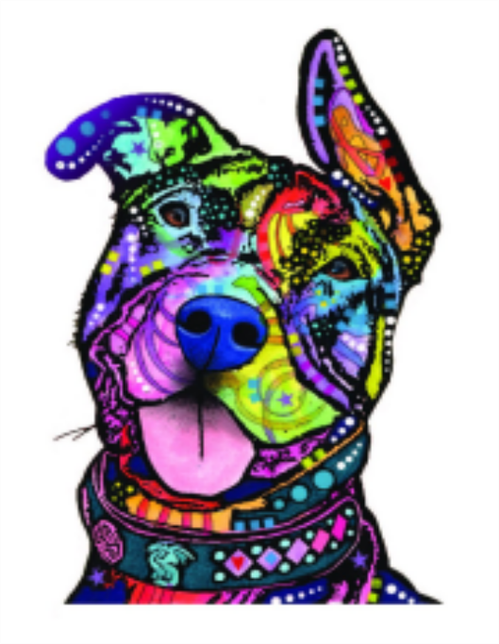

I ______________________ give permission for Paradise Kennels Inc. to preform creative grooming services on my pet _____________________. I acknowledge there are risks involved in this service and release all liability related to these services.

Signature
_______________________Date

